Statistics with R programming

Thanuja R

192325004

19.

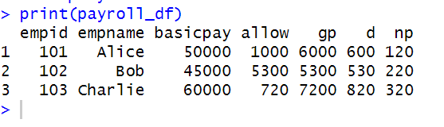

20.

